# **Template – CRM RFI Form**

The template named “Template – CRM RFI Form” is applicable to CampusNexus CRM.

## Purpose and Outcome

This template provides a form sequence and supporting workflow for a basic Request for Information form which captures the users contact details (name, email, etc.) and area of interest (program, term).

The workflow checks the CRM database for a duplicate email address. If a lead record is found with the same email address, the existing lead will be updated with the information provided in the form. If no matching email address is found, a new lead record will be created. Once the lead record is updated or created, the workflow sends a confirmation email to the user. In case of errors, for a better user experience, the form will not show any error messages.

## Prerequisites

The template was built with Forms Builder using the applications listed below. The template is forward compatible with later versions of the listed applications.

|  |  |
| --- | --- |
| **Application** | **Minimum Version** |
| Forms Builder Designer and Renderer | 3.4 |
| Web Client for CampusNexus CRM | 12.0 |
| Workflow Composer | 2.6 |
| Packages installed from Package Manager in Workflow Composer | Activities and Contracts (CRM) 12.0.0  Forms Builder Contracts 3.4 |
| Workflow Tracking Database | N/A |
| Staff STS 2.0 | 2.0 |

## Configuration

The web.config file in the CMCFormsRenderer_V3 folder must contain the following:

* SMTP settings to enable confirmation emails to be sent
* Database connection details to enable the workflow to query the database (see ExecuteDataReader activity.

## Step 1: Download and Import the Template

1. Download the template file to your environment (local drive or network location).
2. Log into **Forms Builder Designer**.
3. Click the **Export/Import** tile.
4. Select the **Import** tab.
5. Click **Select exported file** and navigate to the downloaded template file.
6. Click **Import**.

* [Export/Import](https://help.campusmanagement.com/FB/3.x/Content/ExportImport.htm)

The *CMC Confirmation* and *FB_Lead* forms will be imported:

## Step 2: In Form Designer…

1. From the **Forms** slide out, select the **FB_Lead** form.
2. Customize the form for your environment. Modify properties on fields/components to make them required, etc., or add/remove fields on form.

Make sure you edit the text in the Labels and HTML controls as applicable for your institution.

* [Fields](https://help.campusmanagement.com/FB/3.x/Content/Fields.htm) and [Components](https://help.campusmanagement.com/FB/3.x/Content/Components.htm)

1. **Save** the form.
2. Repeat steps 1-3 for the **CMC Confirmation** form.

## Step 3: In Sequence Designer…

1. Locate the **CRM RFI** sequence in the Sequences pane.
2. Click **Save As** to create a copy of the sequence/workflow and customize the copy for your use. This way you can always refer to the original sequence/workflow you downloaded.
3. Optional - Add a custom style (theme) associated with your campus.

* [Themes](https://help.campusmanagement.com/FB/3.x/Content/Themes.htm)

1. Select your saved sequence in the Sequences pane.
2. In the Properties Pane:
   * Ensure that the **Authentication Product** is **CRM**.

* Select the **End State Form** named “CMC Confirmation”.

1. **Save** the sequence**.**

## Step 4: In Workflow Composer…

This template does not require any changes to the workflow. The steps below just point out the elements in the workflow and to provide references for additional information.

1. Open the workflow for your CRM RFI sequence.

* [Opening Workflows for Sequences](https://help.campusmanagement.com/FB/3.x/Content/HostedEnv.htm)

1. Select the **Arguments** tab and note that the *lead* argument has been created due to entity fields on form.

* [Updating a Form After Creation of a Sequence](https://help.campusmanagement.com/FB/3.x/Content/AddingEntities.htm) and [Binding](https://help.campusmanagement.com/FB/3.x/Content/ComponentBinding.htm).

1. Double-click the **FB_Lead** state and note the CreateEntity<Lead> activity.

* [CreateEntity activity](https://help.campusmanagement.com/WF/Content/Workflow/CreateEntity.htm)

1. Double-click the **Next** transition and note the WaitForFormBookmark activity in the Trigger section.

* [WaitForFormBookmark activity](http://cltcvuehelps/fb/3.x/Content/Workflow/WaitForFormBookmark.htm)

1. The Sequence in the Action section of the Next transition contains a TryCatch activity which provides error handling functionality.

* [TryCatch activity](https://help.campusmanagement.com/WF/Content/Workflow/WF_Activities.htm?Highlight=trycatch" \l "ErrorHandling)

1. Double-click and expand the **Sequence** within the TryCatch activity. Note that the Sequence container holds an ExecuteDataReader activity and an If activity.
2. Review the properties of the **ExecuteDataReader** activity.

The template uses the following property values:

* CommandText = "Select top 1 Aid from tblobjecttype20005 with(nolock) where tleademail= '" & lead.Email & "'"
* ConnectionStringName = "crmconnection"

The ExecuteDataReader activity executes a query on the email addresses in the CRM database. The query will work only if the workflow can connect to the CRM database. Therefore, the following line needs to be added to web.config file in the CMCFormsRenderer_V3 folder of your Forms Builder installation:

**<add name="crmconnection" providerName="System.Data.SqlClient" connectionString="Data Source=crmdb_server;initial catalog=crm_database;Integrated Security=SSPI;Persist Security Info=False;MultipleActiveResultSets=True" />**

Where:

* The name value (in our example “crmconnection”) needs to match the ConnectionStringName in the ExecuteDataReader activity.
* crmdb_server and crm_database need to be set correctly for your environment

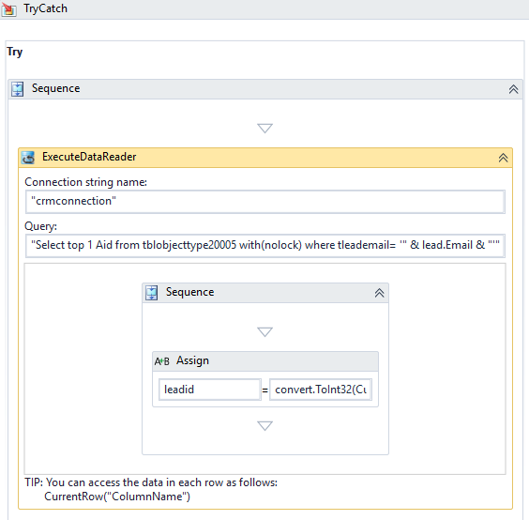

* [ExecutedataReader activity](https://help.campusmanagement.com/WF/Content/Workflow/ExecuteDataReader.htm)

1. Review the logic of the **If** activity.

* If the Condition leadid>1 is met (i.e., an email address matching the form entry was found in the CRM database), then the lead entity is retrieved, and the lead record is updated with the information provided in the form.
* If the Condition leadid>1 is not met (i.e., an email address matching the form entry was not found in the CRM database), then a new lead entity is created with the information provided in the form.

In both cases, a confirmation message is sent.

## Step 5: In Forms Renderer…

Select your sequence and try it out! You should have a new prospect created upon completion.

* [Sequence List](https://help.campusmanagement.com/FB/3.x/Content/SequenceList.htm)

1. Find your **CRM RFI** sequenceand copy the **URL** to the clipboard.
2. Paste the URL into a browser and complete the form sequence.
3. Verify that a confirmation message is sent to the email address provided in the form
4. In CampusNexus CRM, verify that the lead record is updated created containing the information submitted in the RFI form.

## Step 6: Lastly…

Once your updated sequence has been tested successfully, it is recommended that you disable the workflow for the original Template version.

1. In Workflow Composer, in the Server section of the ribbon, click **Open**.
2. Find the workflow named **CRM RFI Sequence**.
3. Clear the **Enabled** check box and click **Save**.